**Selenium Java Project to maven Project**

**Step: 1**- Create a sample java project and your code Sample java program,

**package** test.java;

**import** org.openqa.selenium.By;

**import** org.openqa.selenium.WebDriver;

**import** org.openqa.selenium.chrome.ChromeDriver;

**public** **class** URL {

**public** **static** **void** main(String []k) **throws** Exception{

System.*setProperty*("webdriver.chrome.driver","C:\\Users\\shivendra.pandey\\Downloads\\chromedriver.exe");

WebDriver driver = **new** ChromeDriver();

driver.get("https://www.google.co.in/?gfe_rd=cr&ei=EjlbWbnFPOSK8QeylZ7ACw");

Thread.*sleep*(1000);

driver.manage().window().maximize();

driver.findElement(By.*xpath*("//*[@title='Search']")).sendKeys("sanfoundry");

Thread.*sleep*(1000);

driver.close();

}

}

**Step: 2-** Right click on **java Project**, click on **Configure** navigate **to convert to maven Project.**

Follow, figure 2.1 and figure 2.2

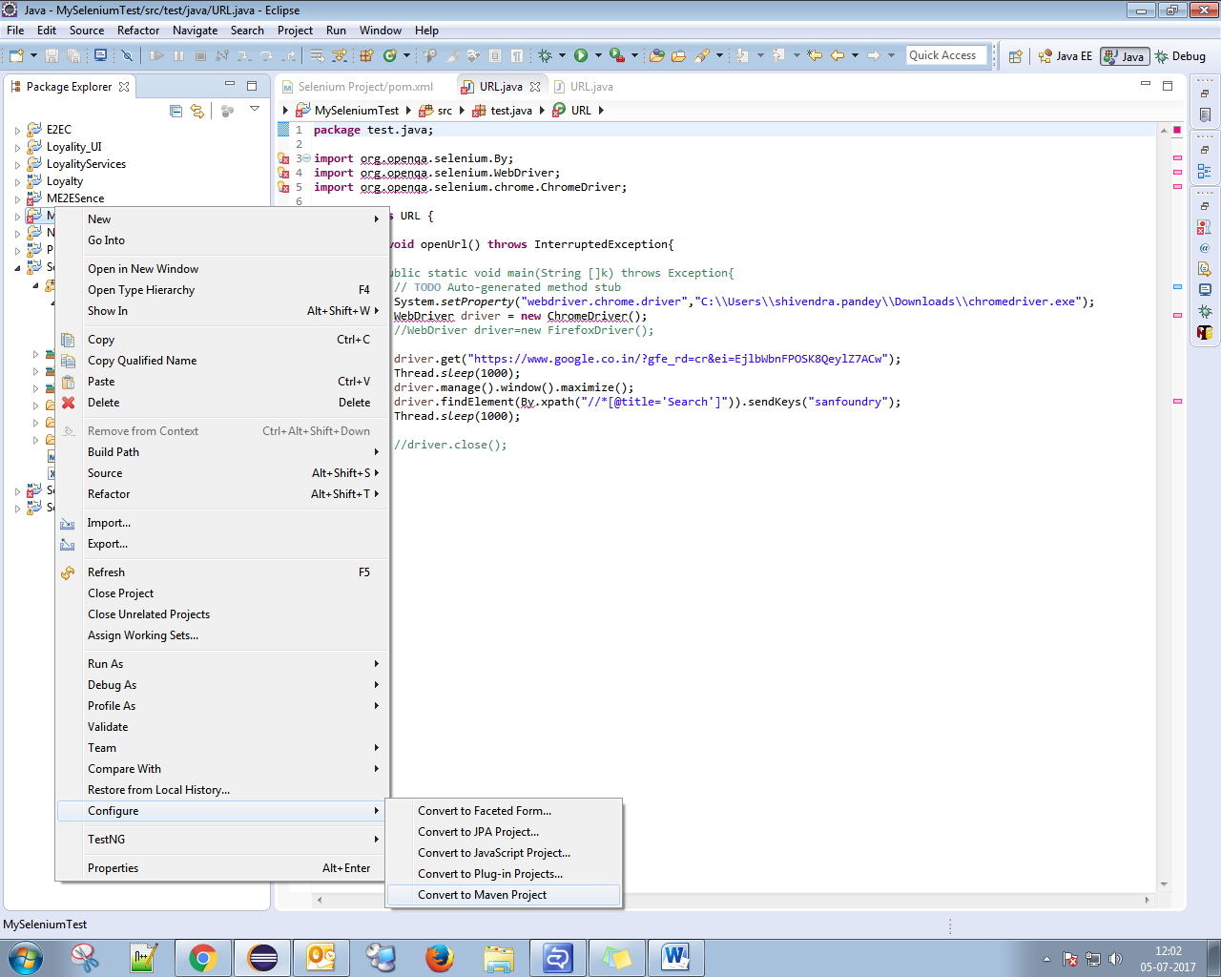

**Figure 2.2**

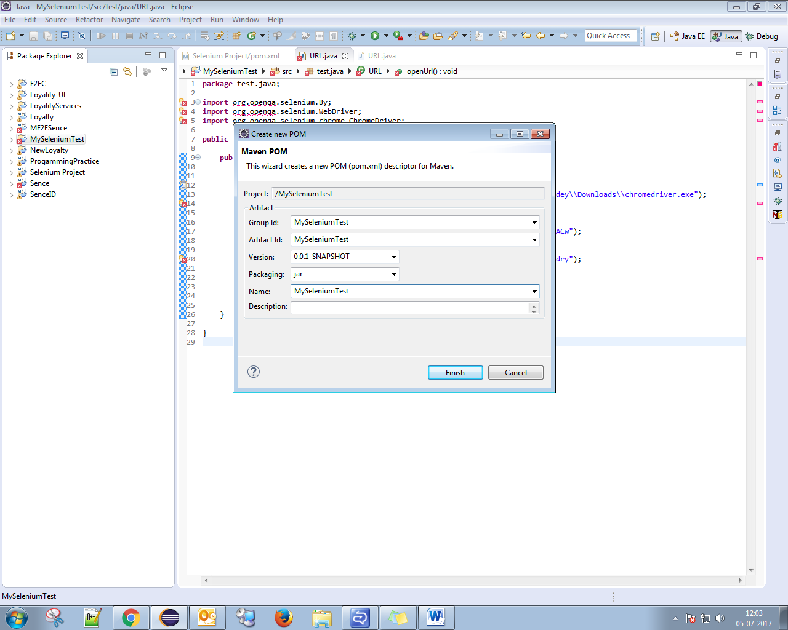

**Step: 3-** Add all dependencies (required jars and plugins surefire-plugin for testing.xml)

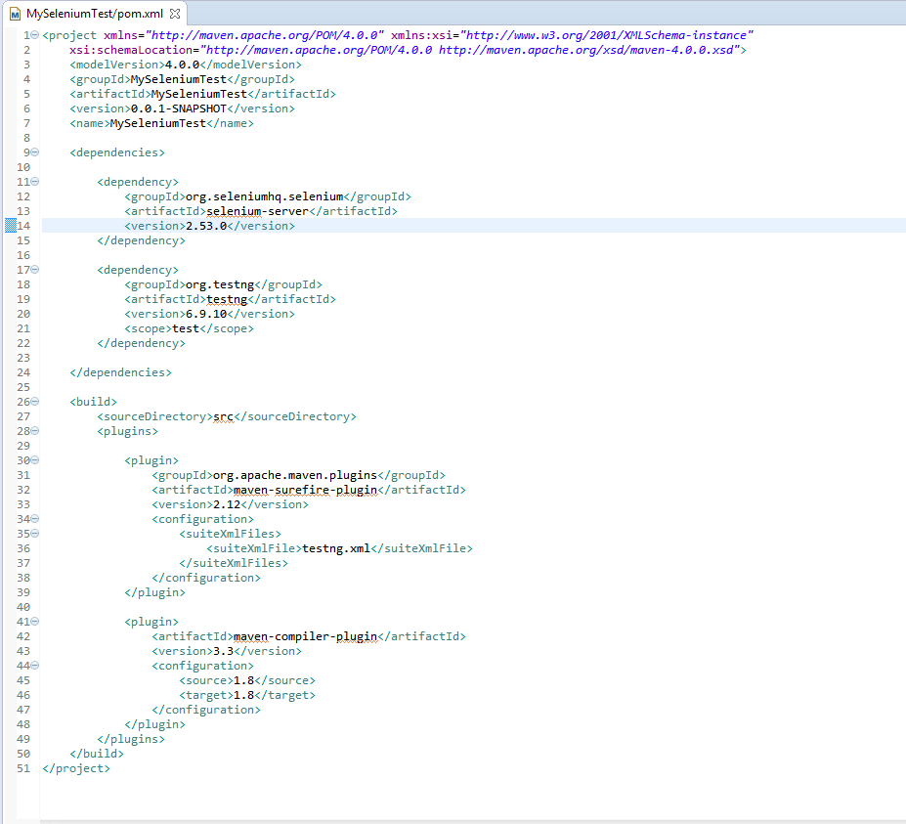

**How to add jars,**

**Way 1**:- Search in “<https://mvnrepository.com/> “ and add the repository

<dependencies>

<dependency>

<groupId>org.seleniumhq.selenium</groupId>

<artifactId>selenium-server</artifactId>

<version>2.53.0</version>

</dependency>

<dependency>

<groupId>org.testng</groupId>

<artifactId>testng</artifactId>

<version>6.9.10</version>

<scope>test</scope>

</dependency>

</dependencies>

<build>

<sourceDirectory>src</sourceDirectory>

<plugins>

<plugin>

<groupId>org.apache.maven.plugins</groupId>

<artifactId>maven-surefire-plugin</artifactId>

<version>2.12</version>

<configuration>

<suiteXmlFiles>

<suiteXmlFile>testng.xml</suiteXmlFile>

</suiteXmlFiles>

</configuration>

</plugin>

<plugin>

<artifactId>maven-compiler-plugin</artifactId>

<version>3.3</version>

<configuration>

<source>1.8</source>

<target>1.8</target>

</configuration>

</plugin>

</plugins>

</build>

**Way: 2-** Add jars from Local system (Chose either way1 or way2 or both if needed)

Create a folder (Say: lib) and place in the same directory

Ex.-

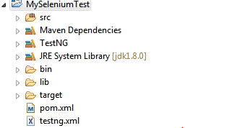

<dependency>

<groupId>selenium-server-standalone-3.3.1</groupId>

<artifactId>selenium-server-standalone-3.3.1</artifactId>

<version>3.3.1</version>

<systemPath>${basedir}/lib/selenium-server-standalone-3.3.1.jar</systemPath>

<scope>system</scope>

</dependency>

**Step: 4:-** Convert your class to testing class

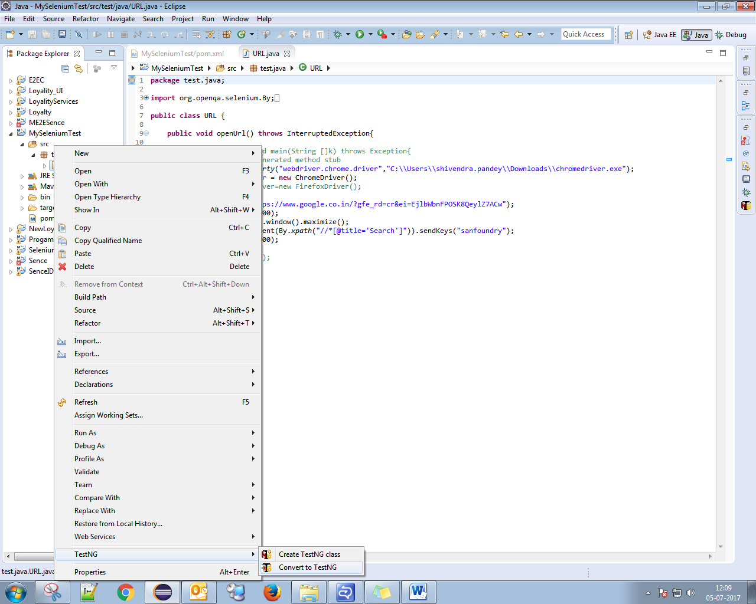

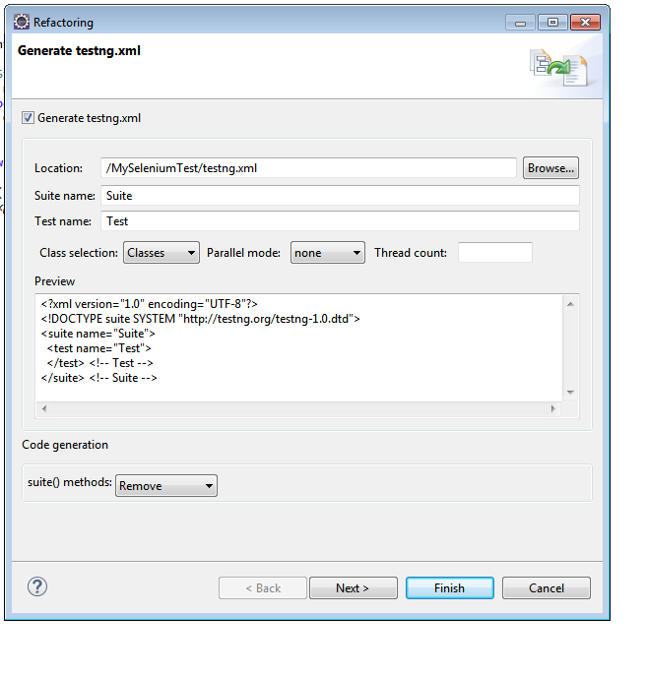

**Step: 5-** Edit testing.xml.

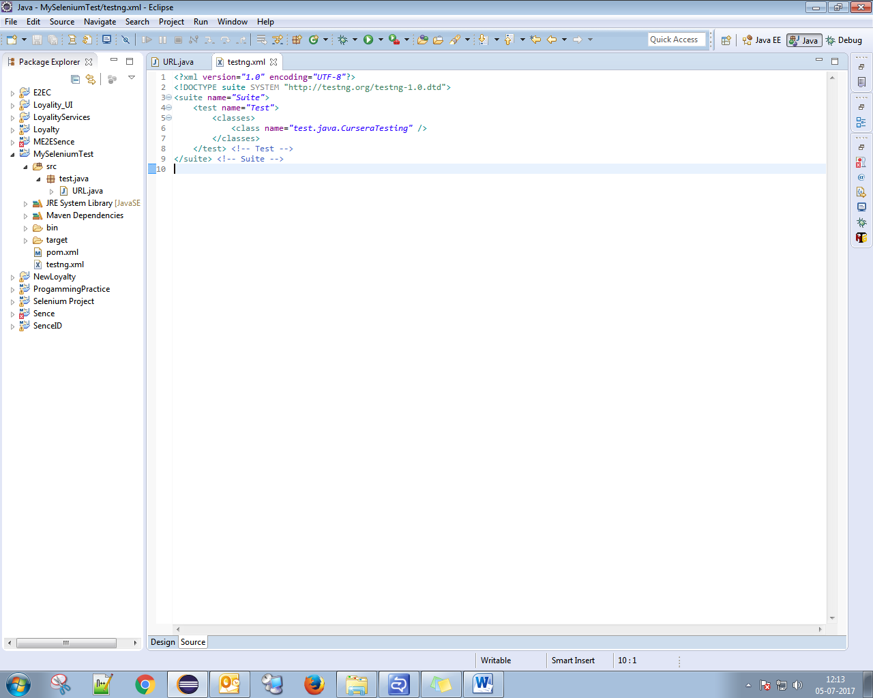

**Provide the class Name save it**

<suite name=*"Suite"*>

<test name=*"Test"*>

<classes>

<class name=*"test.java.CurseraTesting"* />

</classes>

</test> <!-- Test -->

</suite> <!-- Suite -->

**Step: 6- Your class must contain Annotation @Test**

If not, please add. See the below program,

**package** test.java;

**import** org.openqa.selenium.By;

**import** org.openqa.selenium.WebDriver;

**import** org.openqa.selenium.chrome.ChromeDriver;

**import** org.testng.annotations.Test;

**public** **class** URL {

@Test

**public** **void** openUrl() **throws** InterruptedException{

System.*setProperty*("webdriver.chrome.driver","C:\\Users\\shivendra.pandey\\Downloads\\chromedriver.exe");

WebDriver driver = **new** ChromeDriver();

driver.get("https://www.google.co.in/?gfe_rd=cr&ei=EjlbWbnFPOSK8QeylZ7ACw");

Thread.*sleep*(1000);

driver.manage().window().maximize();

driver.findElement(By.*xpath*("//*[@title='Search']")).sendKeys("sanfoundry");

Thread.*sleep*(1000);

driver.close();

}

}

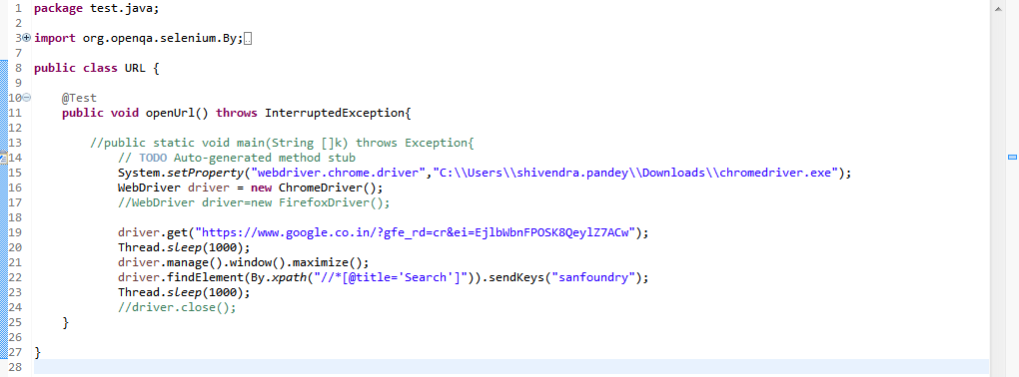

**Step: 7- At the last verify all the setup’s TestNG, JDK**

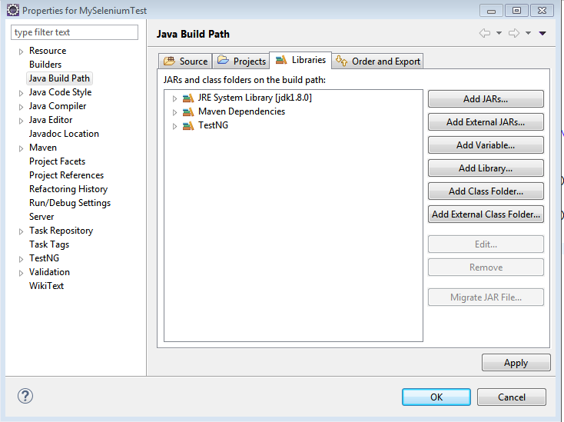

**Step: 8- Directory Structure**

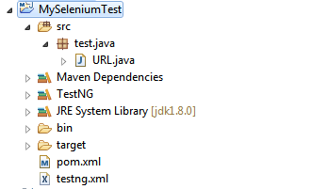

**Step: 9:- Debugging and Running the project.**

**Run your Project.**

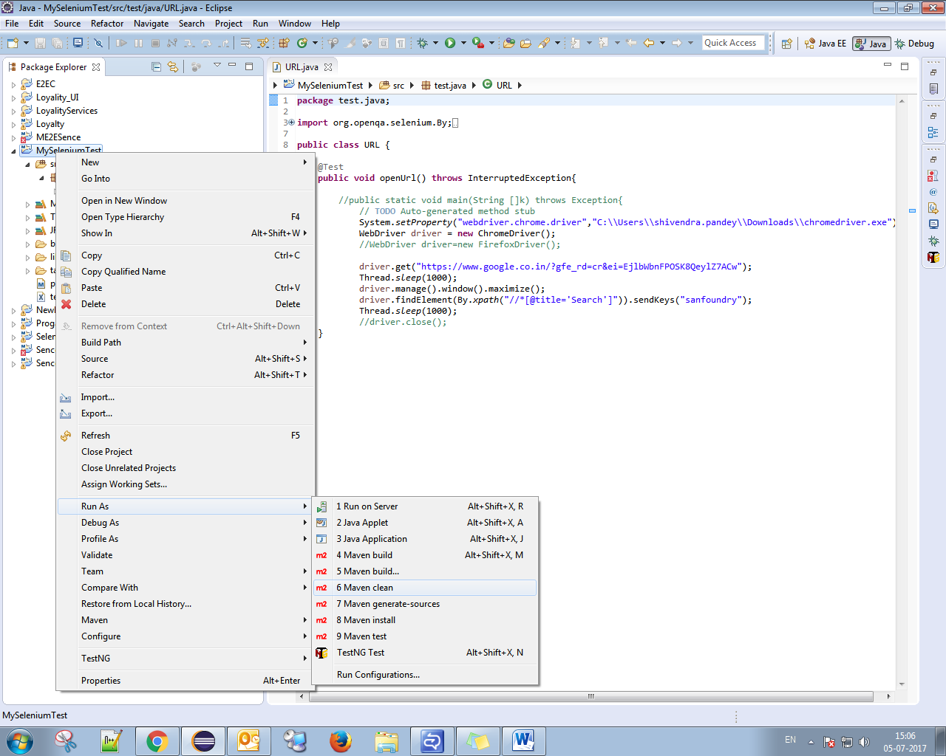

If you are getting error,

**Error 1:- No compiler provided, perhaps running with JRE rather than JDK.**

**Change JRE to JDK**

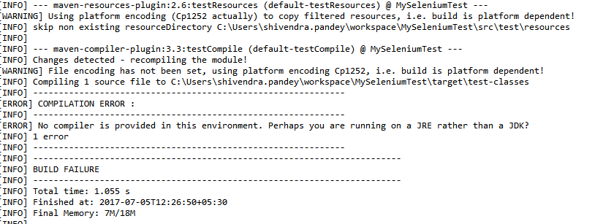

**Error 1:- Unsupported major, minor version 51.0**

**Right click on project properties, left side click on java complier and hange to comptibe version**

**Change Compiler version to 1.8 or compatible**

